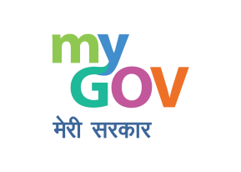



# NEP 2020

National Education Policy 2020

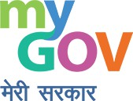**Human Resource Development**

iS!'lil Government of India

Vision of the National Education Policy 2020

An education system that contributes to an equitable and vibrant knowledge society, by providing high-quality education to all

**0**

**e**

Develops a deep sense of respect towards the fundamental rights, duties and Constitutional values, bonding with one's country, and a conscious awareness of one's role and responsibilities in a changing world

Instils skills, values, and dispositions that support responsible commitment to human rights, sustainable development and living, and global well-being, thereby reflecting a truly global citizen

**0**

**Human Resource Development**

'ffi'litlr *;;nm* Government of India

Key Principles of NEP

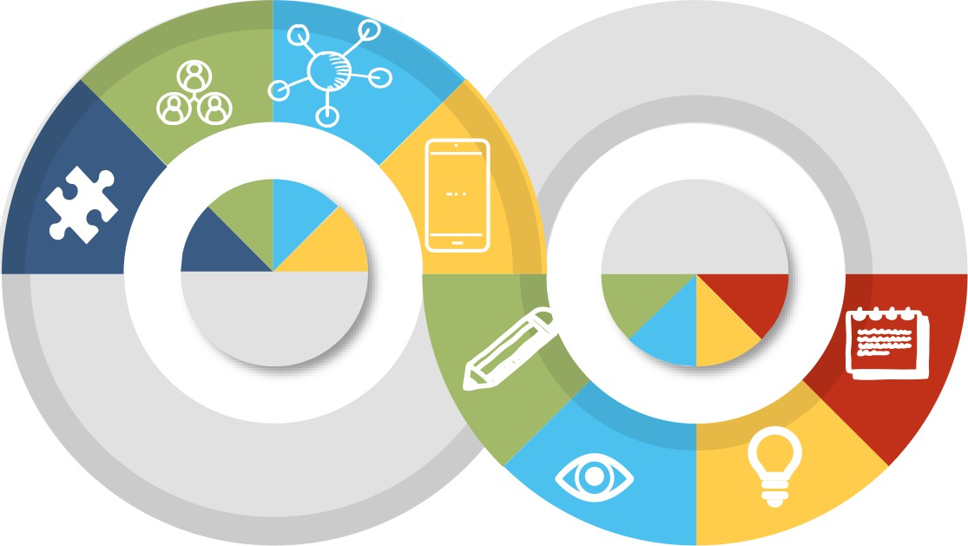**Respect for Diversity & Local Context** In all curriculum, pedagogy, and policy.

**Equity & Inclusion**

As the cornerstone of all educational decisions.

**Community Participation** Encouragement and facilitation for philanthropic, private and community

##### 'Wov

**Emphasize Conceptual Understanding**

Rather than rote learning and learning-for-exams

**Unique Capabilities** Recognizing, identifying them in each student.

**Critical thinking and Creativity**

participation.

To encourage logical decision­

**Use of Technology**

In teaching and learning, removing language barriers, for Divyang students, and in educational planning and management.

making and innovation

**Continuous Review**

Based on sustained research and regular assessment by educational experts.

Universal Access to Early Childhood Care & Education (ECCE)

**Universal Access**

J

For children of 3-6 years: access to free, safe, high quality ECCE at Anganwadis/Pre-school/Balvatika

* 7

:

.

. :

* I
* I

**Foundational Learning Curriculum**

For age group of 3-8 divided in two parts:

(i) From age 3-6 in ECCE and (ii) age 6 to 8 in class I and II in primary school

**Multifaceted**

Flexible, multi-level, play-based, activity-based,and inquiry­ based learning

I

L---------· I

**- Preparatory Class**

Prior to the age of 5 every child will move to a "Preparatory Class" or "Balvatika" (that is, before Class 1)

**Implementation to be jointly carried out by Ministries of HRD, Women and Child Development (WCD), Health and Family Welfare (HFW), and Tribal Affairs**

###### Ensuring Universal Access to Education at all levels

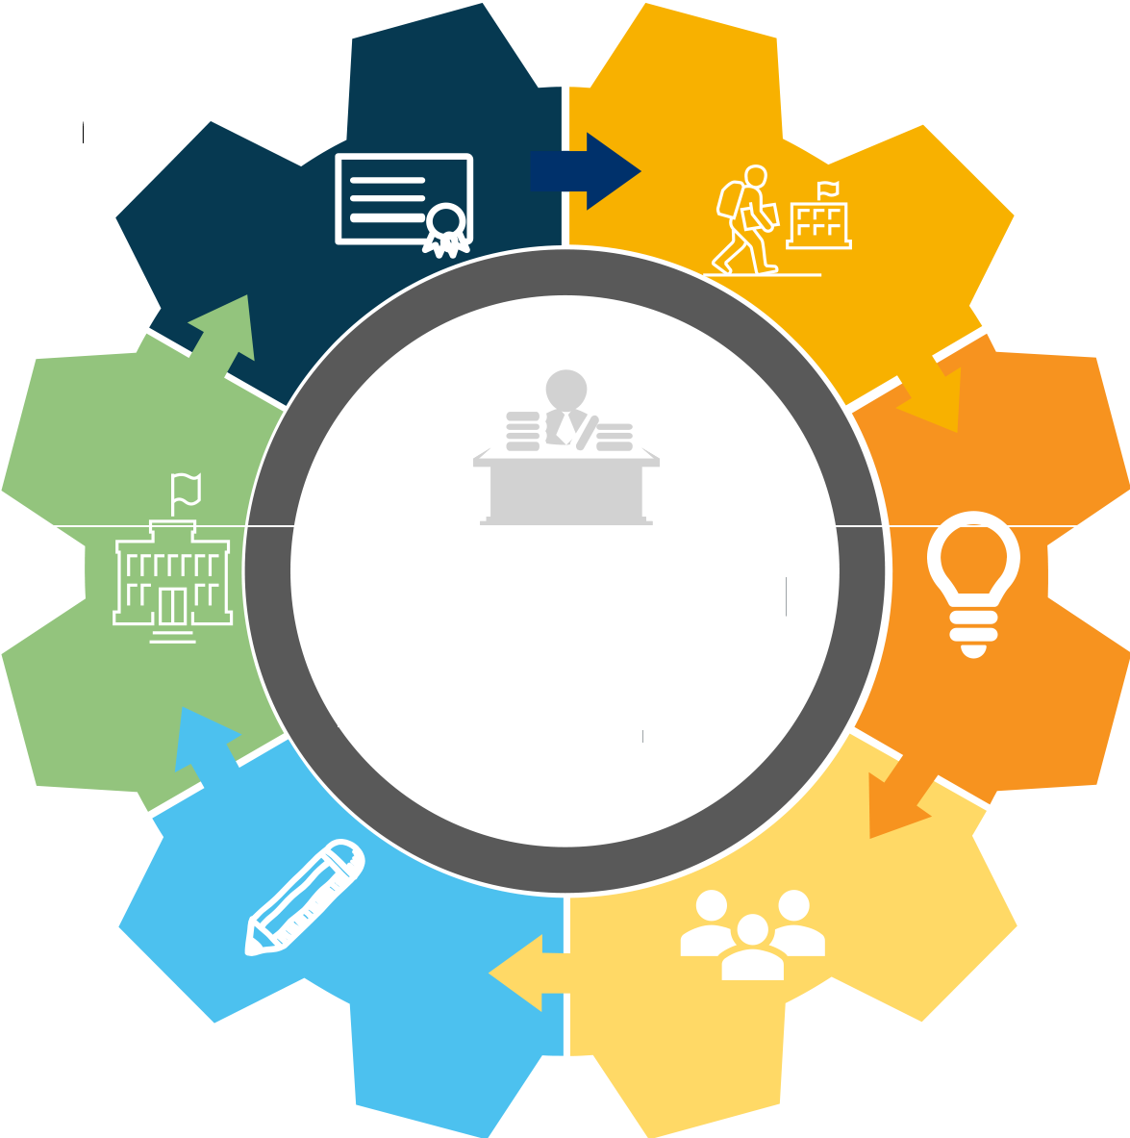**Multiple Pathways** Multiple pathways to learning; involving both

formal and non-formal education modes

**Bring Back Drop-outs**

To bring drop out children back to school

**Build Schools**

Promoting both governments and non-governmental philanthropic organizations to build schools

**Learning Outcomes**

Focus will be on achieving desired learning outcomes at all levels

**To ensure access and opportunity to *a//* children**

**Alternative Centers** Alternative and innovative education centers

**Peer Tutoring**

Suitable for all categories business and personal presentation

Expected Outcomes

* **Universalisation of Access** - from ECCE to Secondary
* Ensure **eguity and inclusion**
* Bring back 2 crores **out-of-school children**
* Attain **SDG goals** of retaining all children in schools until completion of secondary education
* Improve Quality and achievement of learning outcomes - **Foundational Literaci & Numeracy (FLN)**
* Focus on **21st centuri skills** in teaching, learning and assessment
* Resource sharing- **School complexes**



II

* Effective **Governance** - separation of powers and common norms
* Overcoming the **language** barrier in learning
* **Common standards** for public and private school education

###### Transforming Curricular & Pedagogical Structure

**Existing Academic Structure**

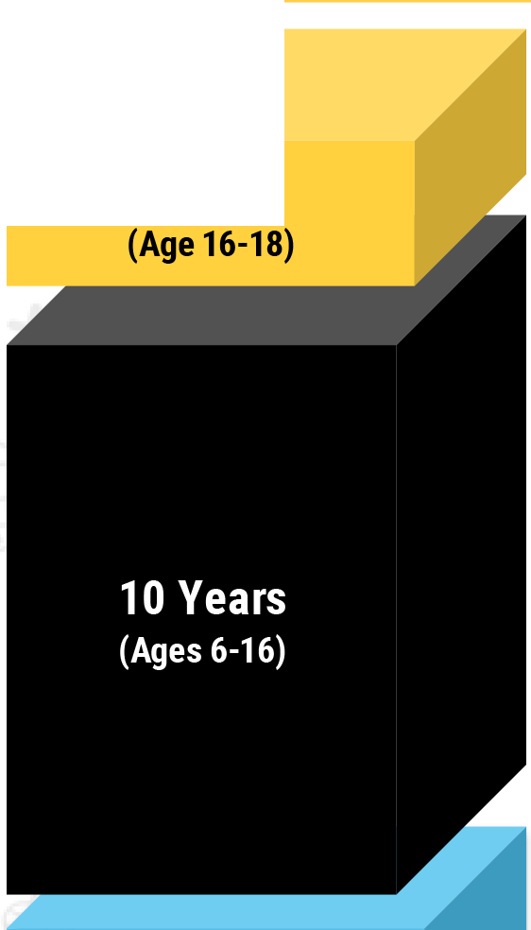

**2 Years**

I **New Academic Structure** I

.>..,.

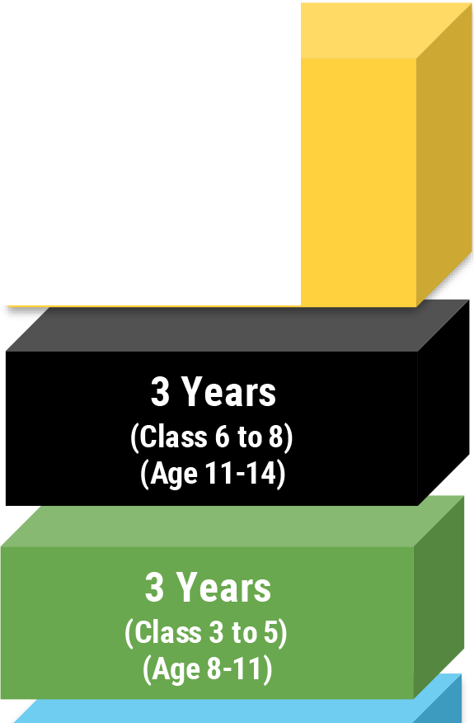

**4 Years**

**(Class 9 to 12)**

**(Age 14-18)**

1. **years**

**{Class 1** & **2) (Ages 6-8)**

1. **years**

**(Anganwadi/ pre­ school/Balvatika) (Ages 3-6)**

**C'CI "'Cl C**

**0**

**c.>**

**CV**

**Cl)**

**CV "'Cl**

**:2**

**::ii:**

**0**

**C'CI**

**C.**

.**C**..**V**.

**Cl..**

**C'CI**

**C 0**

.:;

**C'CI "'Cl C**

=

**0**

**u..**

**New pedagogical and curricular structure of school education (5+3+3+4**): **3 years in Anganwadi/pre-school and 12 years in school**

* + **Secondary Stage(4)** multidisciplinary study, greater critical thinking, flexibility and student choice of subjects
  + **Middle Stage (3)** experiential learning in the sciences, mathematics, arts, social sciences, and humanities
  + **Preparatory Stage (3)** play, discovery, and activity-basedand interactive classroom learning
  + **Foundational stage (5)** multilevel, play/activity-based learning

**Human Resource Development**

'ffi'litlr *;;nm* Government of India

ECCE Framework

NCPFECE

National Curricular and Pedagogical Framework for Early Childhood Education (NCPFECE) will be drafted by NCERT

0 . :<g:

' ~-

# e



o7

##### 'Wov

Multi-faceted Framework



Comprising of alphabets, languages, numbers, counting, colours, shapes, indoor and outdoor play, puzzles and logical thinking, problem-solving,drawing, painting and other visual art, craft, drama and puppetry,

Research and Best Practices

NCPFECE will be aligned with the latest research on ECCE, and national and international best practices

*1!!11*



music and movement

School Preparation Module

A 3-month play-based 'school preparation module' for all Grade 1 students to be developed by NCERT

Early Childhood Education: Learning in the Formative Years

***<ii'***- - Dev-;io;;;n;c;o;ty-,,

',

Logical Thinking &

-- Te;m;:;ork&-- - • **elJt,**

/ / Collaboration

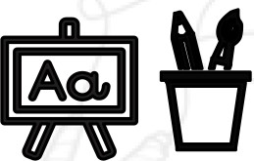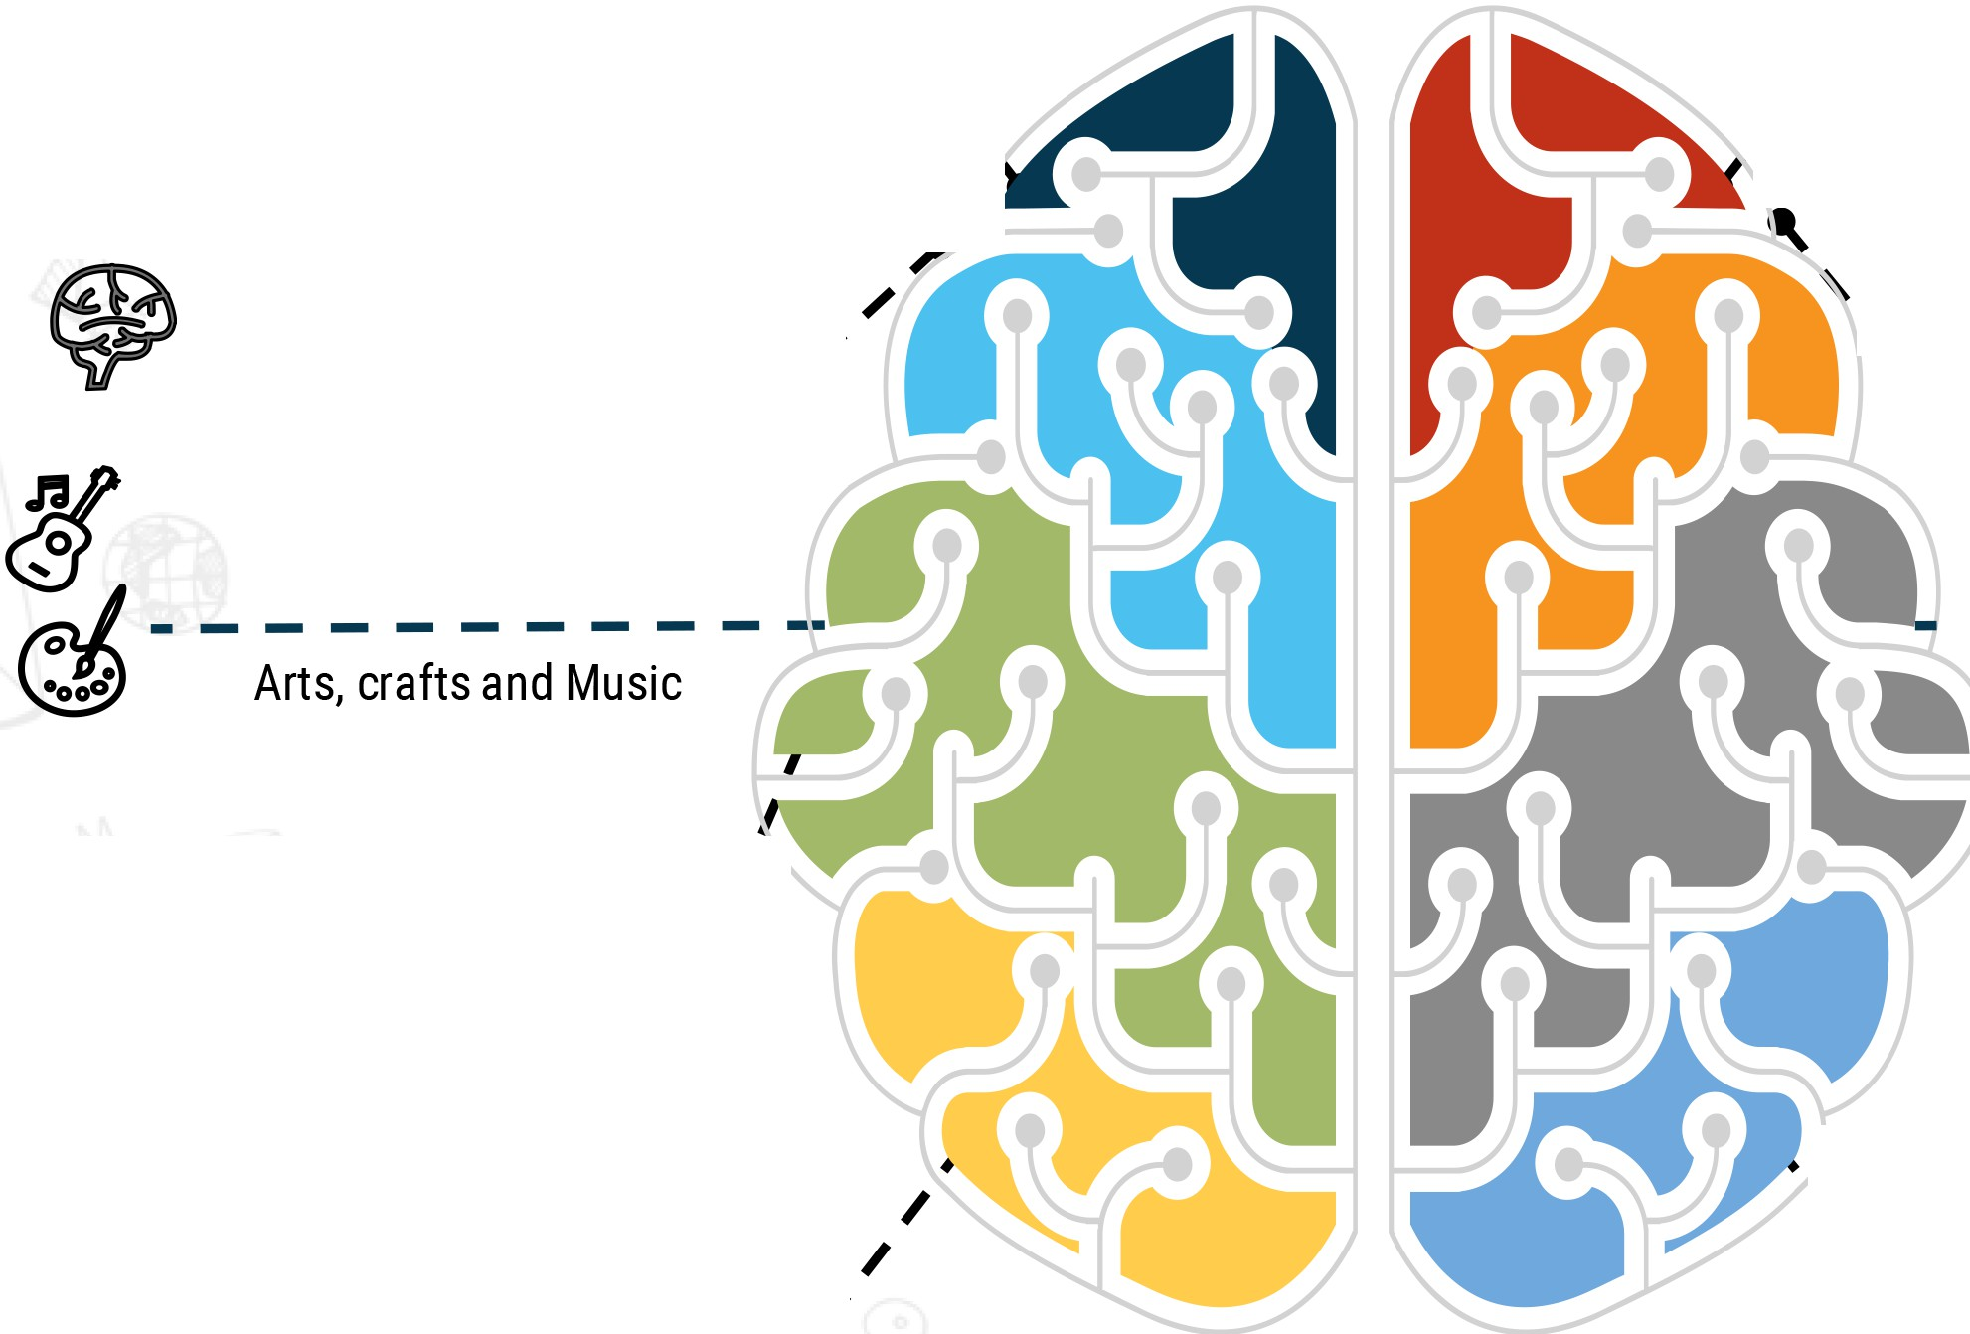

Play-based & Discovery-

'---------

Problem Solving

..../

, based learning

*I*

***J***

Relationship with Nature

- - - - -E;i - - -

•\

' ' '----------

Self-Identity

Colours, Shapes, Alphabets

& Numbers

·-------

, Etiquette, Behaviour and tO,

"----------

, Emotional Development

Attainment of Foundational Literacy And Numeracy by Grade 3 in Mission mode

**Book Promotion**

National Book Promotion Policy will be formulated and public and school libraries will be expanded

**National Mission**

National Mission on Foundational Literacy and Numeracy

**Foundational Skills**

Universal acquisition of foundational learning skills

**Early Learning**

Focus on early reading, writing &

mathematics

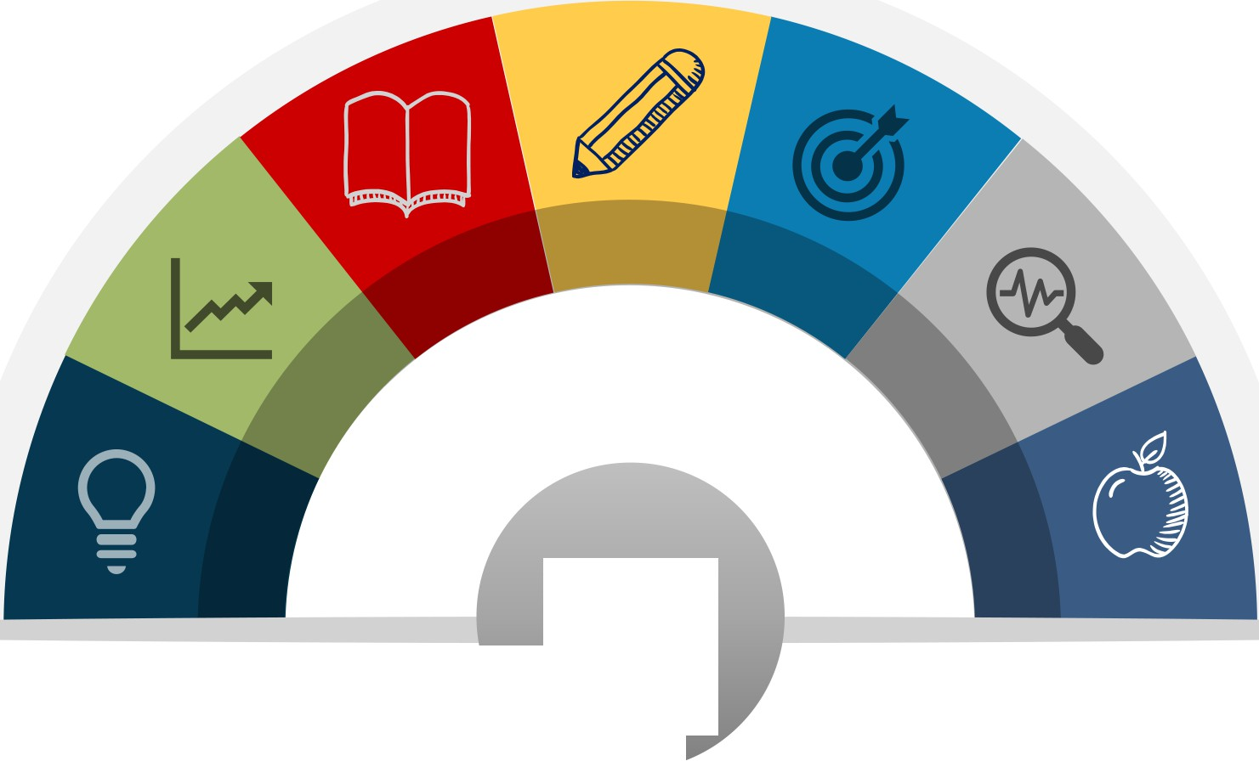

**FLN by Grade 3**

**3-month Play based School**

3-month play-based school preparation module' for all Grade 1 students

**National Repository**

National Repository-High Quality Teaching and Learning Resources on **DIKSHA**

**Libraries**

School libraries, including digital libraries to be leveraged

###### Reduction in Curriculum

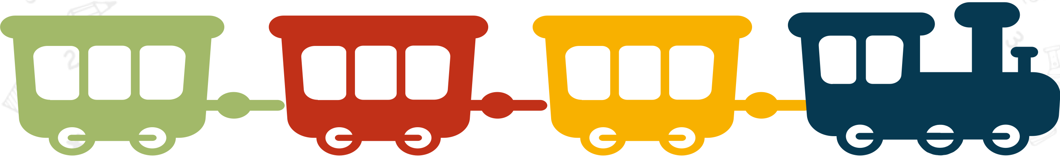

**Core Essentials**

Curriculum in all subjects to be reduced to its core essentials

**Critical Thinking**

Focus on critical thinking, inquiry, discovery, discussion and analysis­ based teaching and learning methods for holistic education

**Interactive Classes**

Interactive teaching with reduced dependency on textbook learning; Questions from students will be promoted

**Experiential Learning**

Fun, creative, collaborative, and exploratory activities in classroom for experiential learning and deeper student learning

•

•

**Curriculum and pedagogy to be transformed by 2022 to promote skill based and minimize rote based**

**learning**

**Revision of NCF for school education and NCF for teacher education 2009 by 2021**

###### Focus on LOs, Competencies and subject - integration



**Competency based education**

Modules on preparing and implementing pedagogical plans based on competency and outcome-based education for school leaders



**NO SILOS among subjects/learning**

**NO** hard separation between:

* curricular/ co-curricuIar/ extra-curricular;
* academic/vocational;
* science/humanities;
* sports/art/academics

**Integration of subjects**

Through arts integrated, sports integrated, ICT integrated and storytelling based pedagogy among others as standard pedagogy

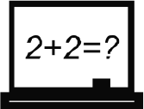

**Emphasis on Digital literacy**

**Development of scientific temper**

Development of scientific temper and inculcation of knowledge and practice of human and constitutional values such as patriotism, sacrifice, non-violence, truth, honesty, peace etc.

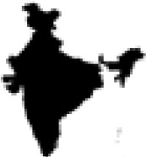

**Promotion of multi-lingual teaching**

Promoting states to enter into bilateral agreements with nearby states to hire language teachers

Emphasis on digital literacy, coding and computational thinking, ethical and moral reasoning

###### Mental and physical health and well-being:

**Mandatory for students to acquire skills in: health and nutrition; physical education, fitness, wellness, and sports**

**Health check ups**

Annual health check up for all students

**Reduce weight of school bags**

Reduced weight of school bags and textbooks through suitable changes in curriculum and pedagogy

**Mandatory skills: Health and Wellness**

Mandatory skills to be imbibed by all students - health, nutrition, physical education, fitness, wellness, sports. In addition- Basic training in preventive health care, mental health, first aid, personal and public hygiene will be included in the curriculum

**Hiring counsellors in school complexes**

State governments will be encouraged to hire adequate number of counsellors and teachers (to be shared across school complex)

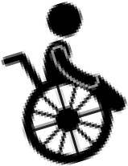**Focus on children with disability**

Differentiated interventions and suitable infrastructure development at schools to make access easier for children with disability

**Inclusive and caring culture at school**

The role and expectations of principal and teachers will explicitly include developing a caring and inclusive culture at school

Innovative Pedagogy: Transforming teaching learning process

Experiential Learning Equal Weightage

Focus on experiential, inquiry • No hard separation between curricular,

•

and discovery based teaching co-curricular and extra curricular area.



learning methods

* Freedom of choosing a variety of subject combination to be provided

Integrated Pedagogy Bagless Days

*  Arts, sports, and story-telling and !CT-integrated pedagogy

Promotion of peer tutoring

* Promoting peer tutoring as voluntary and joyful activity under the supervision of teachers
* Bagless days to be scheduled in academic calendar

Use and integration of technology

* Integration of technology enabled pedagogy in classes 6-12

###### Textbook with local content and flavour

All textbooks to contain only essential core material while capturing any desired nuances and supplementary material as per local contexts and needs

Affordable, high-quality and energised textbooks to be provided along with **free digital version on DIKSHA Platform**



**States to prepare their own curricula** and textbooks based on NCERT curriculum and textbooks, incorporating **State flavour** and material as needed

Concerted efforts, through suitable changes in curriculum and pedagogy to significantly **reduce the weight of school bags and textbooks**



-•-••-

###### India's future and India's leadership role in upcoming fields

**Computational thinking**

Increased emphasis on mathematics and computational thinking throughout the school years

**Mathematical thinking and problem solving**

Inculcate mathematical thinking and problem solving through a variety of innovative methods, including the regular use of puzzles and games



!ill



**Computational thinking**

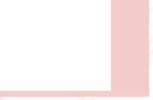Activities involving coding will be introduced in Middle Stage

**Including contemporary subjects in schools**

Teaching of contemporary subjects at middle and secondary stages: Artificial Intelligence, Design Thinking, Holistic Health, Organic Living, Environmental Education, Global Citizenship Education (GCED)

###### Knowledge of India

Students will be given a logical framework for making ethical decisions at a vounq aqe.

Video documentaries on inspirational luminaries of India,

in science and beyond

Will be incorporated in an **accurate and scientific manner** wherever relevant.

**r** Specific courses in tribal ethno-medicinal practices, " forest management, traditional (organic) crop

Traditional Indian values and all basic human and Constitutional values will be developed in all students.

In later years, expanded along themes of cheating, violence, plagiarism, littering, tolerance, equality, empathy.

Indian Knowledge Systems, including **tribal knowledge** and **indigenous and traditional ways of learning,** will be covered.

cultivation, natural farming, etc. will also be made

.. available.

Curriculum to include knowledge from ancient India to modern India as well as future aspirations.

,

Excerpts from the Indian Constitution will also be considered essential reading for all students.

Basic training in health, mental health, good nutrition, personal and public hygiene, disaster response and first­ "'" a-id-w-ill-al-so-b-e i-nc-lud-e-d.- ,

Scientific explanations of the detrimental and damaging effects of alcohol, tobacco, and other drugs

'.. will be part of curriculum.

,

**Human Resource Development**

1;f1@ Government of India

###### Examinations in grades 1 to 8

Key stage assessments

/ I

Census assessments at key stage in classes 3, s

**'Wov**

'ffiif>R

**Moving away from rote learning**

Assessment of core concepts and knowledge, higher-order skills and its application in real-life

*f* and 8 to track achievement

Achievement of critical LOs

Testing to focus on achievement of essential learning outcomes

situations. Moving away from rote learning.

**Results of school examinations**

The results of school examinations will be used only for developmental purposes and for continuous monitoring and improvement of the schooling system

###### Reforming examinations in grades 9 to 12 including board exams

Board exams will be made 'easier', as they will test primarily core capacities/competencies

Viable models to be explored: annual/semester/modular Exams; two parts exams - objective type and descriptive type.

Teachers to be prepared for a transformation in the assessment system by the 2022-23 academic session

Each School Board shall ensure equivalence of academic standards in learner's attainments

Guidelines will be prepared by NCERT, in consultation with SCERTs, Boards of Assessment (BoAs), and PARAKH

eJ

IBeginning with Mathematics, all subjects could be offered at two levels

Standards, norms and guidelines for School Boards through PARAKH National Center

Transforming the culture of assessment

**Continuous tracking** of learning outcomes of each child

I

Board exams to be more flexible, with assessment of essential skills

Assessment to focus on core concepts, higher order and foundational skills

**Al-based software** to help track the progress of the Students to enable them to make optimal career choices.

**National Assessment Centre** will help in bringing greater synergy in board exams conducted by various Boards of Assessments

**Self Assessment and Peer**

I

**Assessment**

**The National Testing Agency (NTA)** wi11 work to offer a high-quality common aptitude test, to eliminate the need for taking coaching for these exams

Holistic Progress Card

States/UTs to redesign Progress Cards in schools to make them holistic, 360-degree, multidimensionalreport

Progress card will include self-assessment, peer assessment, and teacher assessment

Cards to reflect the progress and uniqueness of learner in the cognitive, affective, socio-emotional,and psychomotor domains

Progress in project-based and inquiry­ based learning, quizzes, role plays, group work, portfolios, etc., to be included in report cards

The holistic progress card will actively involve parents in their children's education and development.

Al-based software to be developed to help track growth through school years and to help students make optimal career choices.

Multilingualismand the Power of Language Learning

* 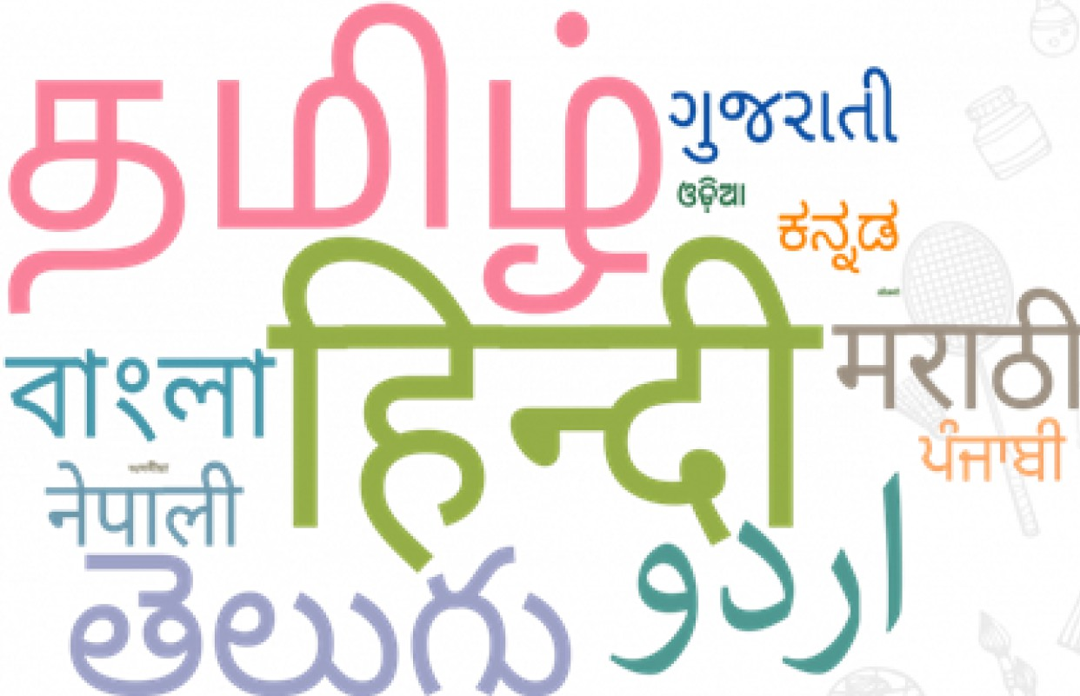 **Medium of instruction** uptil grade 5, and preferably till Grade 8 and beyond, will be **home language/ mother-tongue/ local language**
* **'The Languages of India' a** fun project/ activity on to be taken by every student
* **Three languages** to be taught will be decided by state/UT
* **All classical languages** will be widely available in schools as options

School Complexes/Clusters

**Sharing**



**Resources Governance**

Enable sharing of Effective

human & governance of

infrastructuraI schools resources

**Efficiency Integration**

Efficient Better integration of

expedition and education across all

resourcing for levels through

schools through connected schools

building school and shared teachers

complexes and resources

**BalBhavan**

Strengthening/setting-up of Bal Bhavan for children of all age group to partake in art-related, career-related, and play-related activities

**Samajik Chetna Kendras** Unutilized capacity of schools to be used as Samajik Chetna

Kendra to promote social, intellectual, and voluntary activities

**Planning**

Development of short-term and long-term plans (SDPs)

**Pairing Schools**

Twinning/pairing of one government school with one private school across the country

Ministryof

I

**Human Resource Development**

unra Government of India

#### 'Wov

ffi<liR

###### Standard-setting and Accreditation

To ensure all schools follow **certain mm1mal professional an quality standards**

•

Public and private schools (except the Central Government schools) will be **assessed and accredited** on common minimum criteria

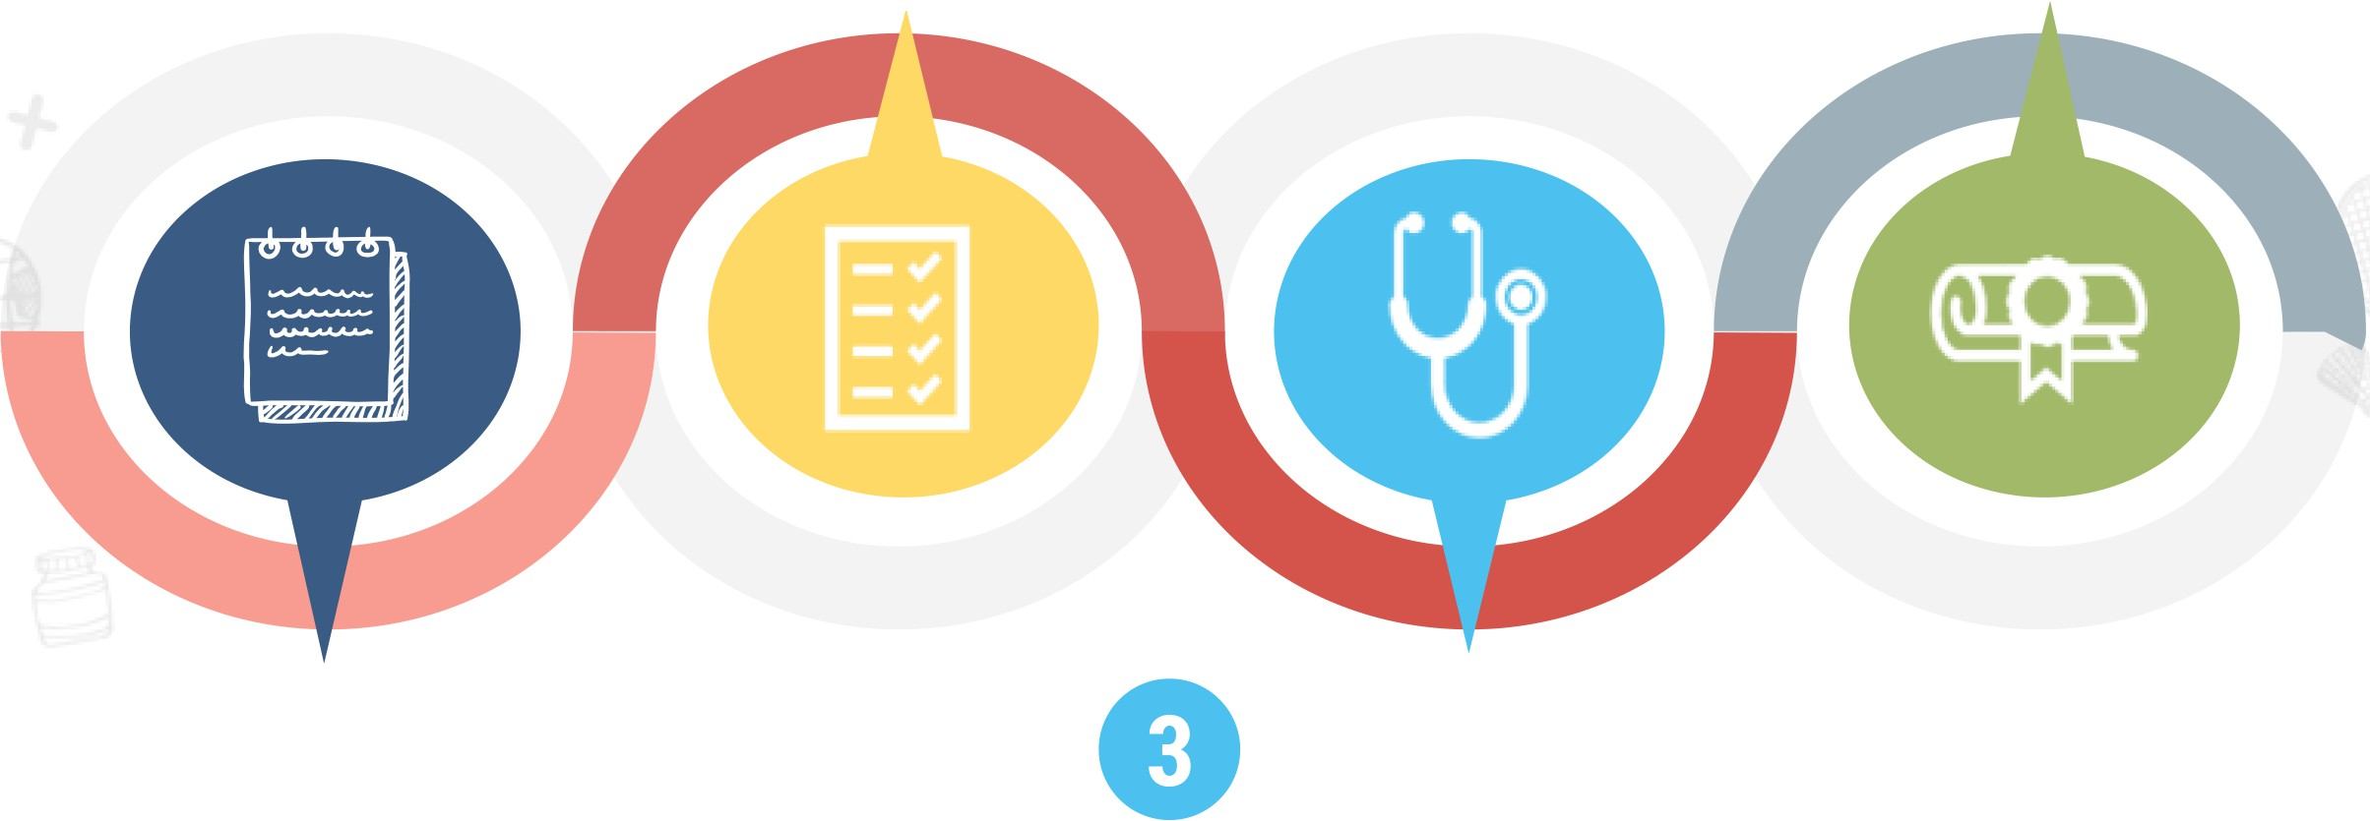Private/philanthropic schools to be encouraged and enabled to play a **beneficial role.**

**0**

### 0

Setting up State School Standards

**Authority(SSSA)**

**Self-disclosure of all the basic regulatory information** of all schools at SSSA and School website

Development of **School Quality Assessment and Accreditation Framework (SQAAF)** by SCERT & NCERT

**Periodic 'health check-up'** of the overall system through a sample-based National Achievement Survey (NAS)

Teacher Education

**4year Integrated**



**B.Ed**

**2 year B.Ed**

**1 year B.Ed**

Minimum degree qualification for teaching that includes student­ teaching at local schools, by 2030

For applicants with an existing Bachelor's Degrees in other specialized subjects

**For those who have completed the equivalent of 4-year multidisciplinary Bachelor's Degrees or have obtained a Master's degree** in **a specialty**

Teacher education will gradually be moved by 2030 into multidisciplinary colleges and universities

Multidisciplinary higher education institutions offering the 4-year in-class integrated B.Ed. programme to also provide blended and or ODL mode of teaching to students in remote areas.

Teacher Education

**4year Integrated**



**B.Ed**

**2 year B.Ed**

**1 year B.Ed**

Minimum degree qualification for teaching that includes student­ teaching at local schools, by 2030

For applicants with an existing Bachelor's Degrees in other specialized subjects

**For those who have completed the equivalent of 4-year multidisciplinary Bachelor's Degrees or have obtained a Master's degree in a specialty**

All B.Ed. programmes will include training in time-tested techniques in pedagogy, multi-level teaching and evaluation, teaching children with disabilities, teaching children with special interests or talents, use of educational technology, and learner-centeredand collaborative learning

Teacher Education

**4year Integrated**



**B.Ed**

**2 year B.Ed**

**1 year B.Ed**

Minimum degree qualification for teaching that includes student­ teaching at local schools, by 2030

For applicants with an existing Bachelor's Degrees in other specialized subjects

For **those who have** completed the **equivalent** of **4-year** multidisciplinary **Bachelor's Degrees or have** obtained **a Master's degree** in **a specialty**

Shorter local teacher education programmes to be available at BITEs, DIETs, or at school complexes for eminent local persons who can be hired to teach at schools as 'master instructors', for promoting local professions, knowledge, and skills, e.g., local art, music, agriculture, business, sports, carpentry, and other vocational crafts

Improving Teacher Education

New and

All teacher education programmes to be conducted within composite multidisciplinary institutions.

Stringent action against substandard stand-alone Teacher Education Institutions (TEis).



.......,,...,.

**I 1•·14 1 f** •

National Higher Education

comprehensive National Curriculum Framework for Teacher Education (by 2021)

NTA testing for admission to B.Ed.

Regulatory Council (NHERC), to function as single point regulator for higher education sector including teacher education

Only educationally­ sound, multidisciplinary, and integrated teacher education programmes to be made available

CD

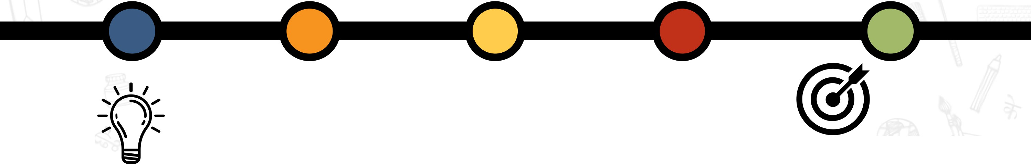Merit based scholarships for 4 year B.Ed. Integrated

Setting-up of National Mission for Mentoring with a large pool of outstanding

senior/ retired faculty

Teacher Eligibility Tests (TETs) at all stages will be strengthened

Teacher recruitment and deployment

**Strengthening TETs**

Teacher Eligibility Tests (TETs) for all teachers

**Transparent transfer system**

Online computerized system for teacher

**0**

across Foundational, Preparatory, Middle and transfers to ensure transparency Secondary stage in both public and private

**0**

schools **Test score and demonstration** - **part of**

**recruitment**

**Tech based planning for teacher recruitment** Subject score from TET or NTA tests and classroom demonstration to be taken

**0**

Technology-based planning and forecasting of into account for recruitment of subject

teacher-requirement to assess expected teachers

**0**

subject-wise teacher vacancies over next two decades

**0 Restructuring of NCTE**

**Certificate Courses** NCTE to be restructured as a

Developing specialization for subject or

Professional Standard Setting Body

generalist teachers, teaching children with (PSSB) under General Education Council

**0**

disabilities/ Divyang children, during pre-service (GEC) teacher preparation with synergy between NCTE

and RCI

Empowering Teachers

A **technology-based** comprehensive teacher-requirement planning forecasting exercise to be conducted by each State.

**Career growth** to be available for teachers within a single school stage i.e., Foundational, Preparatory, Middle, or

Secondary

National Professional Standards for Teachers **(NPST)** by 2022

Improving **Service Environment** through better

infrastructure at school

Teachers to have more **autonomy** in choosing aspects of pedagogy in classroom teaching

**Academic leadership** positions to be made available for teachers.

**Teacher Professional Development**

* Merit based tenure track system
* Min. 50 hours of Continuous Professional Development (CPD)

School Leadership

Necessary facilities for the initial professional preparation of these educators and their Continuous Professional Development (CPD)

CPD opportunities will, in particular, systematically cover the latest pedagogies





.......,,...,.

**I 1•·14 1 f** ,_

## CD

At least 50 hours of CPD for

teachers based on their own interest and professional areas

Ample opportunity to get upskilled on latest pedagogy related to foundational literacy and numeracy, formative and adaptive assessment of learning outcomes, individualised and competency-based learning and related pedagogies

Focus on Socio-Economically Disadvantaged Groups (SEDGs)

**SEDGs** can be broadly categorized based on:

* **Gender identities** (particularly female and transgender individuals),
* **Socio-cultural identities** (such as Scheduled Castes, Scheduled Tribes, OBCs, and minorities),
* **Geographical identities** (such as students from villages, small towns, and aspirational districts),
* **Disabilities** (including learning disabilities), and
* **Socio-economic conditions** (such as migrant communities, low income households, children in vulnerable situations, victims of or children of victims of trafficking, orphans including child beggars in urban areas, and the urban poor).

/

**Separate strategies will be formulated for focused attention for reducing each of the category-wise gaps in school education.**

'

Ministryof

I

**Human Resource Development**

unra Government of India

###### Ensuring Equity

**Interventions**

The critical problems and recommendationsregarding ECCE, foundational literacyand numeracy, access, enrolment and attendance will be targeted in a concerted wayfor

**SEZs**

Large populations from SEDGs to be declared Special

Education Zones {SEZs) **Fee Waivers**

Fee waivers and scholarships will be offered to meritorious students from all

#### 'Wov

ffi<liR

Socio=EconomicallyDisadvantaged

groups - SEDGs.

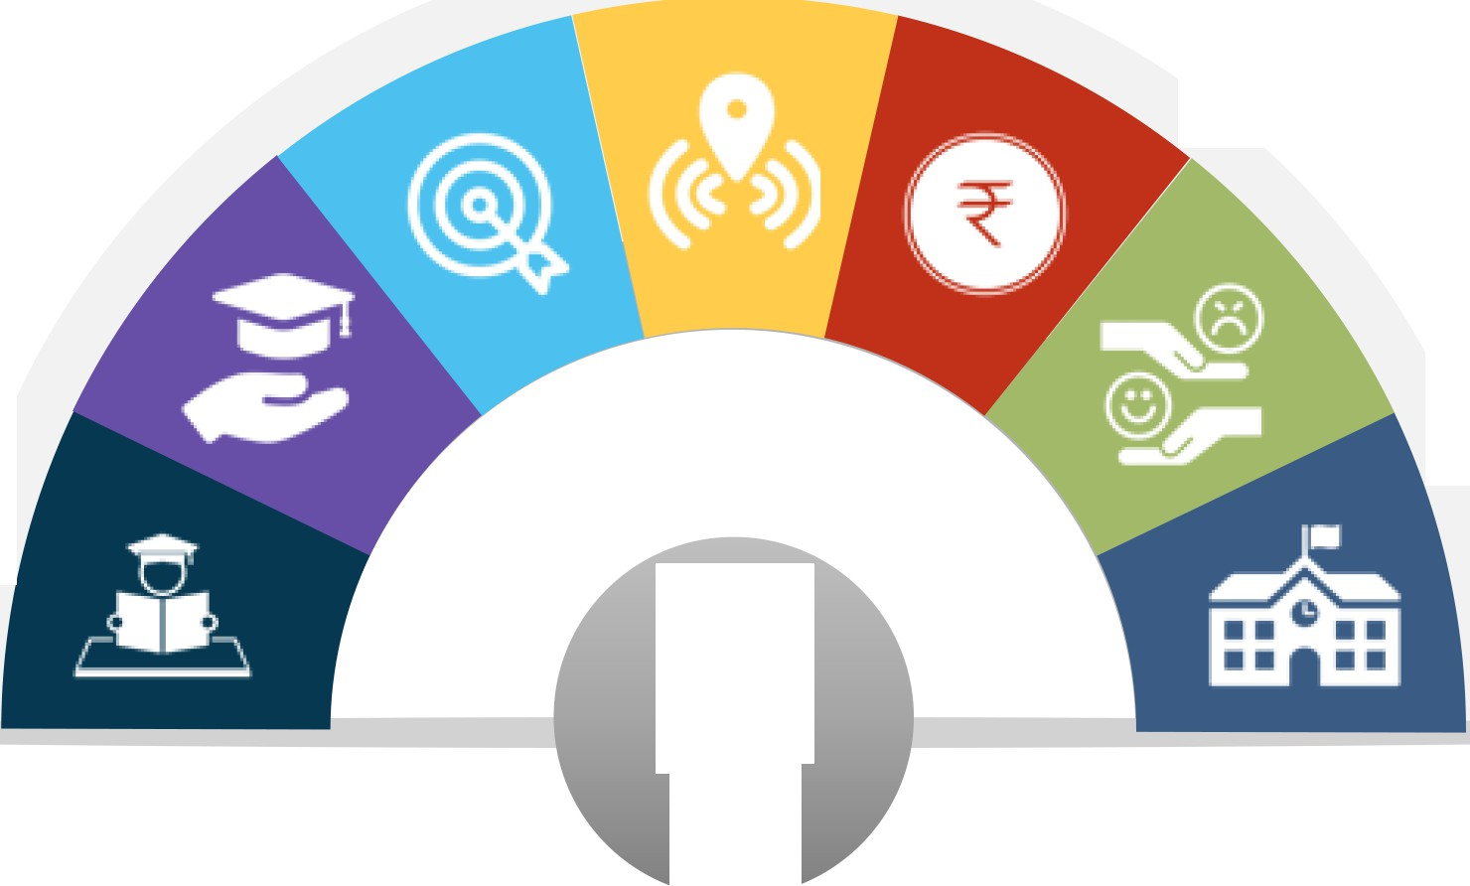

**Special Mechanisms**

Special mechanisms for children belonging to tribal groups to receive quality education

SEDGs on a larger scale

**Counsellors**

Recruitment of counsellors in schools

**Learning Outcomes**

Focus on attainment of learning outcomes of children belonging to SC/ST/OBC

**EQUITY**

**Additional Schools**

Setting-up of additional JNVs and KVS in aspirational districts/SEZs

**Human Resource Development**

s;i,rn Government of India

WU -=-r_,.JLiUu:.1

tl@rc;r;-i11i:.r.10000□□lt}

*e2 rBBf* J

JOOO\ ICTicnffilQ.J

**Gender Inclusion Fund**

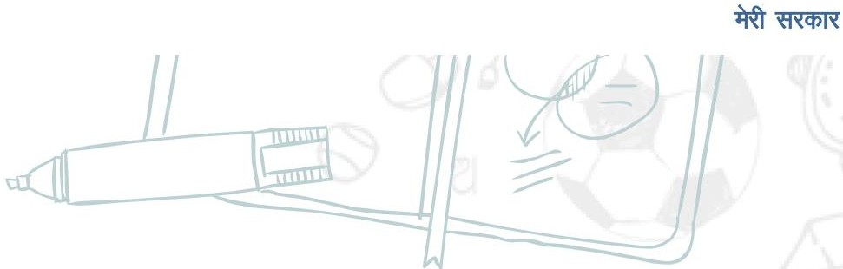Gender-Inclusion Fund for female and

#### 'Wov

- transgender students

J **Safety and Rights**

**Bridging Gender Gap**

Careful attention to safety and rights of all children particularly girls

to retain them in school

Focus on bridging the Gender Gap and provide equal opportunities to all.

I **KGBVs**

Strengthening and extension of

KGBVs up to grade 12

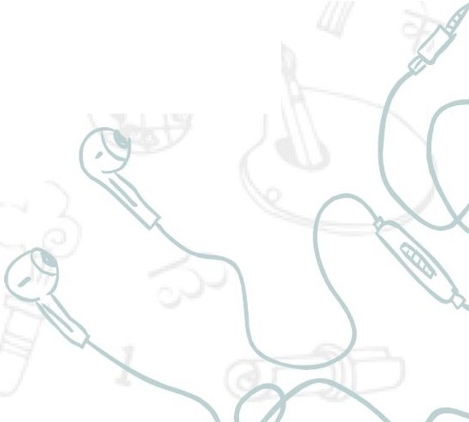Thrust on designing policies and

**Policies targeted for Girls** *r-i;*

schemes targeted towards female

students in the SEDGs

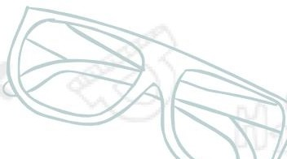**Gender Sensitivity**

'Gender Sensitivity' to be an integral part of curriculum

**Human Resource Development**

iS!'lil Government of India

Supporting Children with Special Needs (CWSN)

**Regular Schooling**

Children with special needs will be integrated in the regular schooling process from elementary to higher education levels

**Enabling Mechanisms**

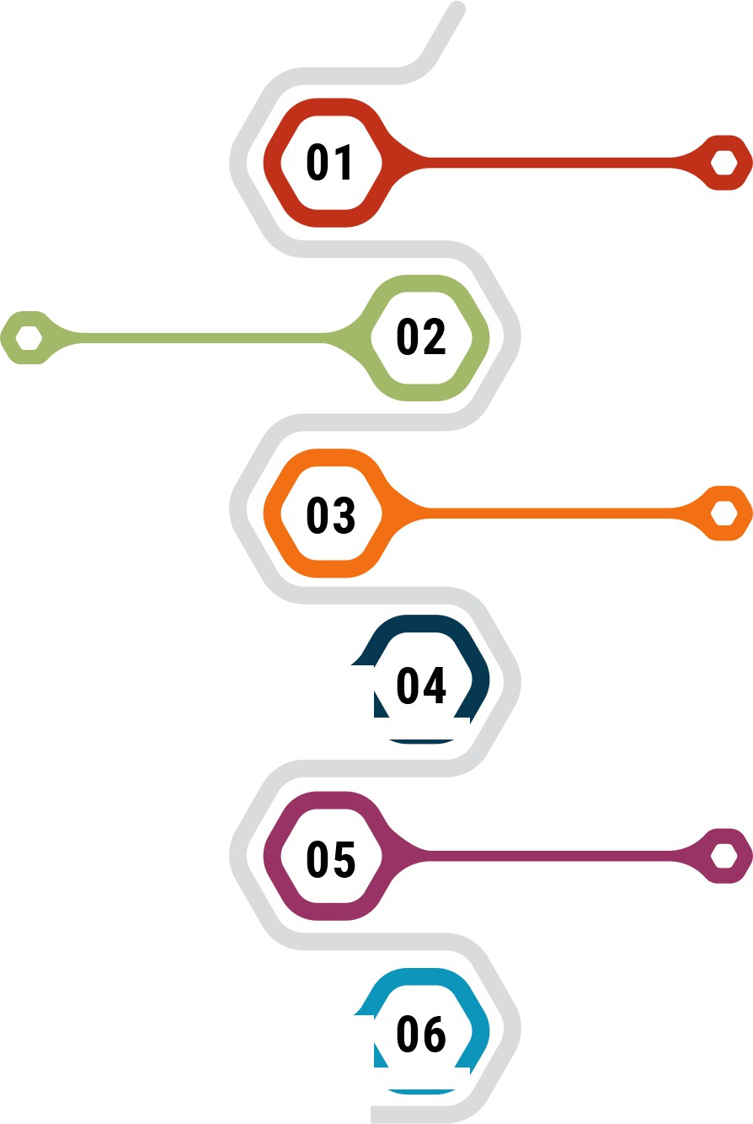Enabling mechanisms for CWSN or Divyang to receive quality education

**Assistive Devices and Orientation to Parents**

Technology enabled assistive devices/tool for CWSN and orientation of the tools/devices for parents/caregivers

|  |  |  |
| --- | --- | --- |
| **Modules** |  | |
| NIOS will develop high-quality modules to teach Indian Sign Language | **0--- •** | ..... |
| **Certificate Courses** |  |  |
| Certificate courses for pre-service and in-service teachers to become special | **0--- •** | ..... |
| educators |  |  |

**Alternative Schools**

Alternative forms of schools will be encouraged to preserve the alternative pedagogical styles

Ministryof

I

**Human Resource Development**

unra Government of India

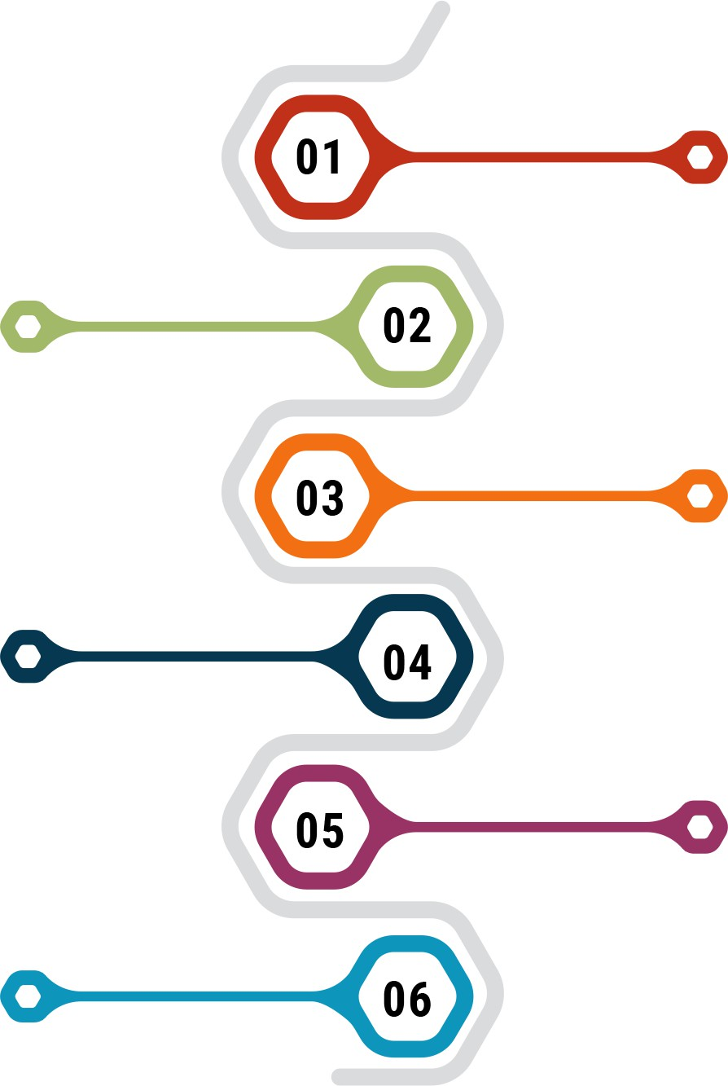Integrating Vocational Education at All Levels

**Practice Based Curriculum**

A practice-based curriculum for Grades 6-8 to be appropriately designed

**LokVidya**

'LokVidya', knowledge developed in India, will be made accessible to students

#### 'Wov

ffi<liR

**Skill Gap Analysis**

Focus areas based on skills gap analysis and mapping of local opportunities

**Open Distance Learning Mode**

Courses to be offered through Open and Distance Learning (ODL) mode.

**Exposure to vocational education**

By 2025, at least 50% of learners shall have exposure to vocational education

**Skills Framework**

National Skills Qualifications Framework will be detailed further for each discipline vocation/ profession

**Vocational Crafts**

All students of grades 6-8 will intern with local vocational experts such as carpenters, gardeners, potters, artists, etc.to develop a vocational craft

**Setting up of PARAKH**

**PARAKH**

Setting-up of National Center for Performance

Assessment, Review and Analysis of Knowledge • • • • • • • • • • •:

**l!I Assessments**

* • • • • • • • • • Shift towards competency based assessments

for Holistic development (PARAKH) : **A, 21st Century Skills**

- .... I Promoting critical and creative thinking aligned to the 21st century in classrooms

Objectives of **PARAKH**

* Setting norms, standards and guidelines for assessment and evaluation
* Guiding the State Achievement Survey (SAS)
* Conducting the National Achievement Survey (NAS)
* Monitoring achievement of Learning Outcomes in the country

###### Support For Gifted Students/ Students With Special Talents

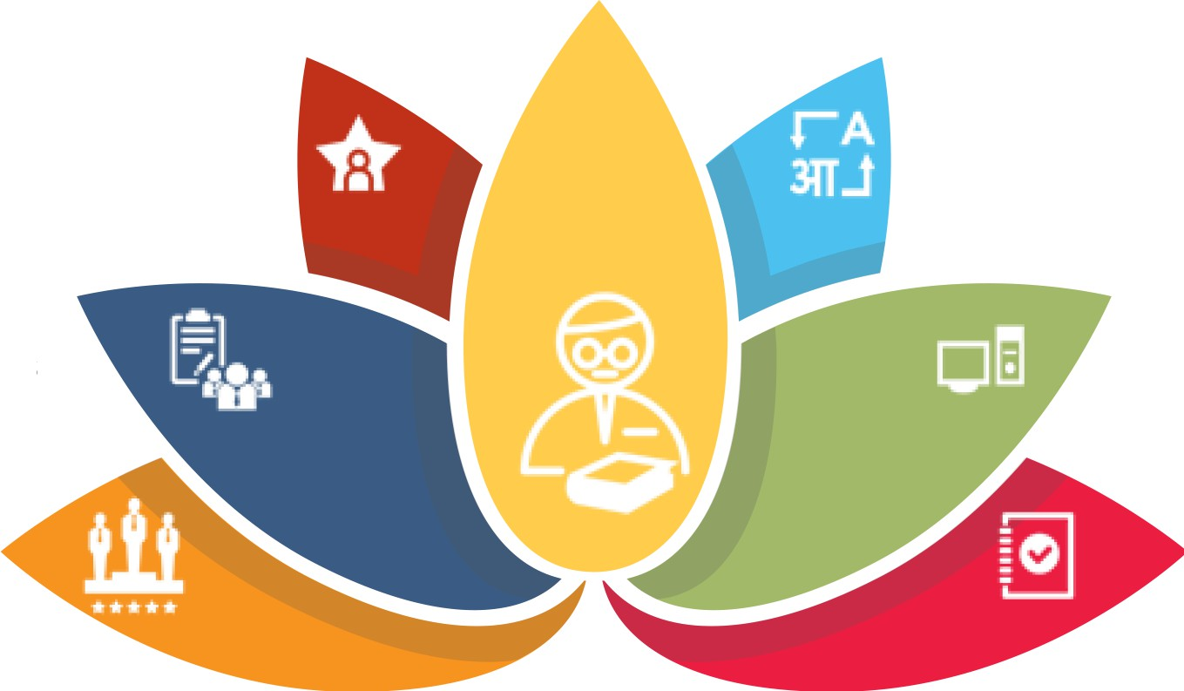**Encourage gifted/talented students**

Pursue realm beyond the general school

curriculum

Efforts for interventions in **rural areas and in regional languages** to ensure widespread participation

Project-based **clubs** to be encouraged and supported and supported at all levels in schools

**Extensive use of technology** to encourage talented/gifted children

**Olympiads and competitions** in various subjects to be conducted

across the country

**NCERT and NCTE will develop guidelines** for the education of gifted children

**B.Ed. Programmes** to allow specialisation in education of gifted children

Ministryof

I

**Human Resource Development**

unra Government of India

#### 'Wov

ffi<liR

###### Online and Digital Education

**Inclusion and Access**

I

Enhance Educational Access To Disadvantaged Groups including Divyang students

**Blended Learning**

**Digital Platforms**

Digital platforms and ongoing ICT­ based educational initiatives to be optimized and expanded

I

**Pilot Studies**

I

#### ONE NAT ON

**ONEDICITALPLATFORM**



**w**

**p**

**DIXSHA.**

Emphasis on effective models of blended learning

A series of conducted

pilot studies to be

**Content Creation**

Content creation, digital repository, and dissemination. Technology Integration In Teaching, Learning & Assessment

**Expansion of Platforms**

Expansion of existing e-leaming platforms- DIKSHA, SWAYAM, etc.

I

-- -**m**

Ministryof

I

**Human Resource Development**

unra Government of India

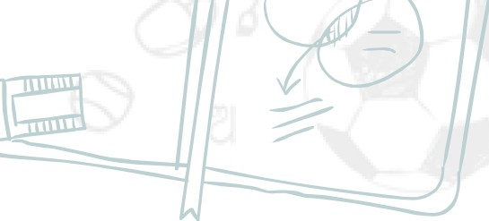

*I*

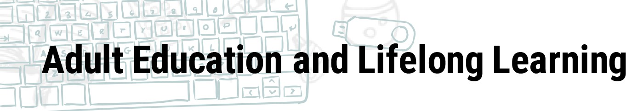

**Innovative Initiatives**

Innovative initiatives for adults with the help of community participation and

technology integration

**Integration with HEls**

Integration of Adult Education Centres (AECs) with HEls and other

public institutions

#### 'Wov

**The Adult Education Curriculum**

**To Include Following Five Types Of** '

**Programme:**

1. Foundational Literacy And Numeracy
2. Critical Life Skills

..-

**Technology Based Options**

1. Vocational Skills Development

....-:=:-- Technology-based high quality options for

adult learning such as apps, online courses/modules, satellite-based TV

channels

1. Basic Education /
2. 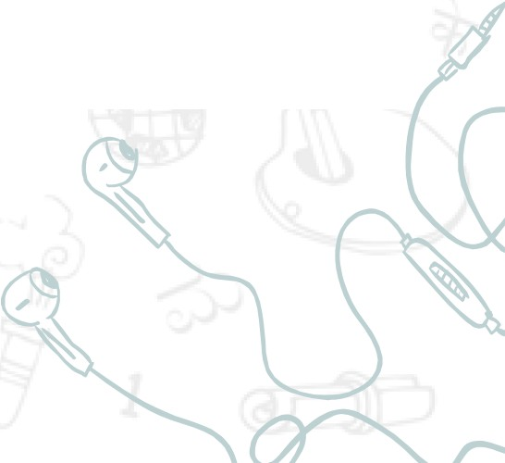Continuing Education

." **Online Books**

1 Online books, !CT-equipped libraries, Adult Education Centres, etc.to be developed through government and

*1*

philanthropic initiatives

I I //

Timeline for Implementation of ECE and new Assessment pattern

**Early ChiIdhood Education**

Initiating implementation of 1 year of pre-primary

school and 3-month ---------

preparatory module for

Class -1 students

**(Phase1)**

Expansion of 1 year of pre-primary school through primary schools and Anganwadis

**(Phase 2)**

- •

**2021-22 2022-23 2023-24 2024-25 2025-26**

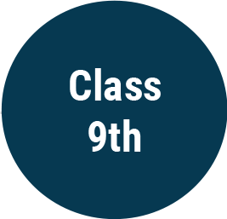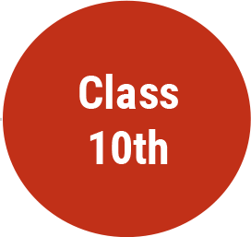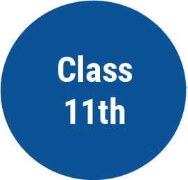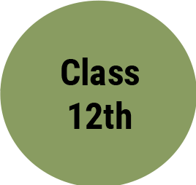

**Implementation of new curriculum and assessment**



**New Board Exam pattern** for

**Class 12th**

New Board Exam pattern for

**Class10th** ---

I

###### Timelines for Implementation in NEP 2020

**Formulation National Curricular Framework for School Education (NCFSE)**

Attaining universal foundational literacy and numeracy in all primary schools for all learners by grade 3

**Universal provisioning of quality early childhood development, care**

Policy is fully operational following this a comprehensive review will be

undertaken

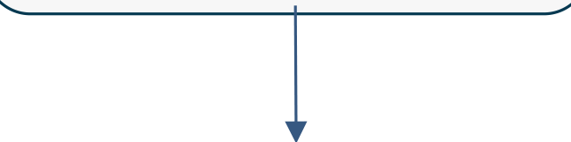**2021-22 2022-23 2023-24 2024-25 2025-26 2026-27 2027-28 2028-29 2029-30**

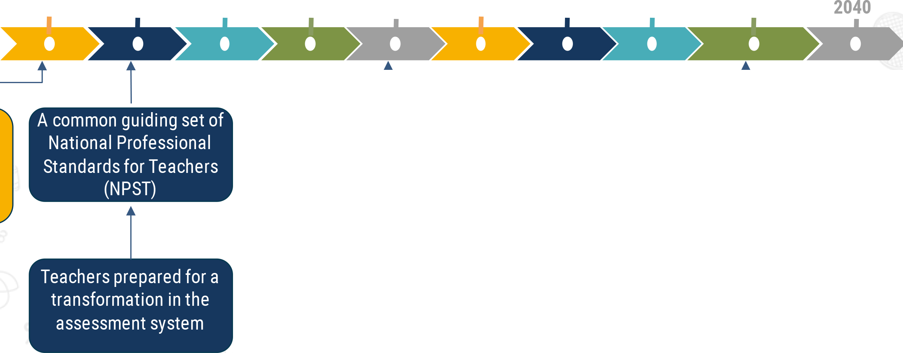

National Curriculum Framework for Teacher

Education

State/UT governments to optimize resources through mechanisms to group or rationalize schools, such as, school complexes

t

At least 50% of learners exposed to vocational education in the school and higher education system

**Teacher education will gradually be moved into multidisciplinarycolleges and universities, with minimum deg. qualification 4-year B.Ed.**

**Only educationally sound, multidisciplinary,and integrated teacher education programmes shall be in force and all TEis will be converted into multi-disciplinary institutes**

###### New Features (1/3)

Preparation for Schooling and Elementary Schooling Level

* ECCE for all by 2030: National Curriculum Framework for ECCE
* Achieve 100% Gross Enrolment Ratio in school education by 2030
* Preparatory **class/Balvatika** for 5-6 year old children in Anganwadis/pre-schools
* School Preparation module for all class 1 entrants
* **National Foundational Literacy and Numeracy Mission**
* Setup of Bal Bhavans

School Infrastructure and Resources

* + Special Education Zones (SEZ)
  + Utilize unused capacity of schools as Samajik Chetna Kendras
  + School complex/clusters for resource sharing

Holistic Development of the Student

* +  No hard separation of curricular, extra and co-curricular, arts and science, sports and vocational crafts. Curriculum to integrate Indian culture and ethos
  + **Innovative pedagogies** to be explored such as experiential teaching/learning methods
  + Book promotion policy and digital libraries
  + **Holistic Report card** - use Al for identifying specific aptitude of child
  + **Vocational education** integration from primary grades and a ten days (no bag days) internship with local trades/craftsperson for Grades 6-8
  + *Lok Vidya* - *local artists as master instructors in schools*

###### New Features (2/3)

lnclusivity

* **Gender Inclusion Fund;** KGBVs upto class 12
* Special provisions for **Gifted children**
* **Adult Education (AE)** to focus upon technology based solutions; NCF for AE to be developed
* NIOS to expand to include vocational courses and courses for grades 3, 5 and 8
* Medium of instruction will be in the mother tongue/local language till Grade 5 (atleast)

Assessments

* National Assessment Center for Performance Assessment, Review and Analysis of Knowledge for Holistic development - **PARAKH**
* Exams in Grades 3, 5 and 8 , in addition to Board exams in Grades 10 and 12
* Board exams: Modular, low stakes, based on conceptual knowledge and its application

Curriculum and Pedagogical Framework

* **New curricular and pedagogical framework** of 5+3+3+4
* Reduction in curriculum to core concepts
* Identification of life skills to be attained in each grade as a part of NCF
* Alternative model of schools to be encouraged to adopt NCF
* **ICT integration** in teaching and learning methodologies
* Tracking students as well as their learning levels; universalisation of secondary education

###### New Features (3/3)

Teacher Recruitments/ Teacher Education

* Minimum qualification degree for teaching will be a 4-year integrated B.Ed. degree by 2030
* Teacher recruitment based on TET, NTA test and teaching demonstration; TET mandatory for teaching
* Minimum 50 hours of in-service training per teacher/year
* National Professional Standards for Teachers (NPST) by 2022
* IT and data based predictive planning for requirement of students in TEis; TEis to move to multidisciplinary colleges and universities by 2030
* Stringent action on non-performing TEis
* Mandatory for every PhD student to do a module on teacher education

Role of Government Departments/Bodies/Institutions

* **State Department** to look after policy making; **Directorate of Education** to look after operations, **SCERT** to look after academics and **State School Standards Authority** to set minimum common standards for online self-disclosure by all public and private schools
* Random sampling of students for continuous online feedback on self-disclosure by schools
* Engagement of social workers, alumni, retired teachers and volunteers with schools
* Strengthening the **Central Advisory Board of Education (CABE)** for developing, articulating, evaluating and revising the vision of education on a continuous basis in collaboration with MHRD and corresponding apex bodies of States
* Its desirable that **Ministry of Human Resource Development MHRD)** be re-designated as Ministry of Education (MoE) to bring the focus back on education and learning